**Response time, sec**

|  |  |  |  |  |  |  |  |  |  |  |  |  |  |  |  |  |  |  |  |  |  |
| --- | --- | --- | --- | --- | --- | --- | --- | --- | --- | --- | --- | --- | --- | --- | --- | --- | --- | --- | --- | --- | --- |
| Name | Users | 0 | 1 | 2 | 3 | 4 | 5 | 6 | 7 | 8 | 9 | 10 | 10 | 10 | 10 | 10 | 10 | 10 | 10 | 10 | 10 |
|  |  |  |  |  |  |  |  |  |  |  |  |  |  |  |  |  |  |  |  |  |  |
| Facilities | Avg | 0 | 2,75 | 2,66 | 2,93 | 3,68 | 2,86 | 3,0 | 2,91 | 3,27 | 2,46 | 2,86 | 3,91 | 4,91 | 6,07 | 5,03 | 2,89 | 3,69 | 4,15 | 6,13 | 4,86 |
|  | Avg90 | 0 | 3,17 | 3,52 | 3,8 | 4,43 | 4,4 | 4,76 | 4,44 | 5,02 | 4,1 | 4,81 | 6,44 | 8,26 | 10,7 | 7,67 | 5,15 | 6,33 | 6,98 | 10,5 | 7,99 |
|  | Max | 0 | 3,25 | 4,1 | 4,04 | 5,19 | 6,18 | 5,89 | 6,05 | 5,58 | 5,36 | 7,25 | 11,0 | 10,1 | 19,0 | 14,0 | 6,7 | 8,85 | 13,0 | 13,2 | 8,86 |
|  |  |  |  |  |  |  |  |  |  |  |  |  |  |  |  |  |  |  |  |  |  |
| Confidentiality | Avg | 0 | 1,67 | 1,08 | 1,22 | 0,93 | 1,53 | 1,5 | 1,21 | 1,44 | 1,66 | 1,38 | 2,09 | 1,41 | 3,53 | 2,63 | 1,6 | 2,36 | 2,7 | 1,91 | 1,78 |
|  | Avg90 | 0 | 2,11 | 1,9 | 2,02 | 1,57 | 2,7 | 2,74 | 2,29 | 2,64 | 3,25 | 2,67 | 4,33 | 3,54 | 7,71 | 7,0 | 3,18 | 5,05 | 5,93 | 3,79 | 3,76 |
|  | Max | 0 | 2,21 | 2,21 | 2,25 | 1,94 | 4,06 | 3,61 | 3,46 | 3,57 | 6,29 | 4,07 | 6,94 | 10,2 | 8,85 | 11,5 | 5,92 | 10,5 | 8,67 | 6,64 | 6,45 |

**Facilities**

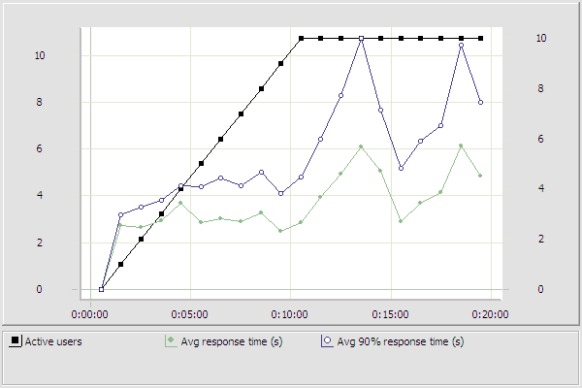

**Confidentiality**

